Spectral coherence: AUDUSD and EURGBP
Method 21 / daily log returns / Welch magnitude-squared coherence / Alpari D1 full available history

Study setup
Logical pair: AUDUSD , EURGBP
Broker symbols: AUDUSD_i , EURGBP_i
Snapshot: 2026-11-03_majors_alpari_D1
Timeframe: D1
Matched return window: 1999-01-06 to 2026-11-02 (UTC bar dates)
Matched return count n: 7198
Dropped unfinished last bar dated 2026-11-03 UTC after a tick-volume check against the prior complete day.
Welch: fs=1.0, nperseg=256, noverlap=128, window=hann, detrend=constant
Headline: gamma^2 nearest f=1/5; also 1/21 and 1/63
Complete matched rows (Excel): AUDUSD-EURGBP_Spectral_D1.xlsx
Complete matched rows (HTML table): AUDUSD-EURGBP_Spectral_D1_data.html

Method carried forward
Magnitude-squared spectral coherence gamma^2(f) measures shared linear power between matched daily log returns of close, ln(close_t / close_t-1), at each frequency f (cycles per day). Quotes are not inverted. Welch settings are frozen: fs=1, nperseg=256, noverlap=128, window=hann, detrend=constant. Headline is gamma^2 at the frequency bin nearest f=1/5 (five-day cycle from the formula sheet). Also reported: gamma^2 nearest f=1/21 and f=1/63, mean gamma^2 over the frequency grid, and phase of the cross-spectrum at the 1/5 bin. Coherence is unsigned (0 to 1); phase carries timing. Same-sample Pearson r is a side check only. This is not causation and not a trading signal.

Results (headline)
gamma^2 near 1/5: 0.003754
bin f (1/5): 0.199219
phase at 1/5 (rad): -1.310955
gamma^2 near 1/21: 0.036596
gamma^2 near 1/63: 0.037033
mean gamma^2: 0.034149
Pearson r: 0.038173

Target-frequency summary
period | target_f | f_bin | gamma2 | phase_rad
5 | 0.2 | 0.19921875 | 0.00375443 | -1.3109553
21 | 0.04761905 | 0.046875 | 0.03659632 | 1.3390622
63 | 0.01587302 | 0.015625 | 0.03703259 | 0.60245528

Conclusion
Headline gamma^2 near f=1/5 for AUDUSD and EURGBP: 0.0038 (bin f=0.199219, phase=-1.3110 rad). At ~1/21: 0.0366; at ~1/63: 0.0370. Mean gamma^2 = 0.0341. Pearson r = 0.0382. This is frequency-domain linkage, not a trading signal.

Charts
Daily closes

Daily log returns

Spectral coherence gamma^2(f)
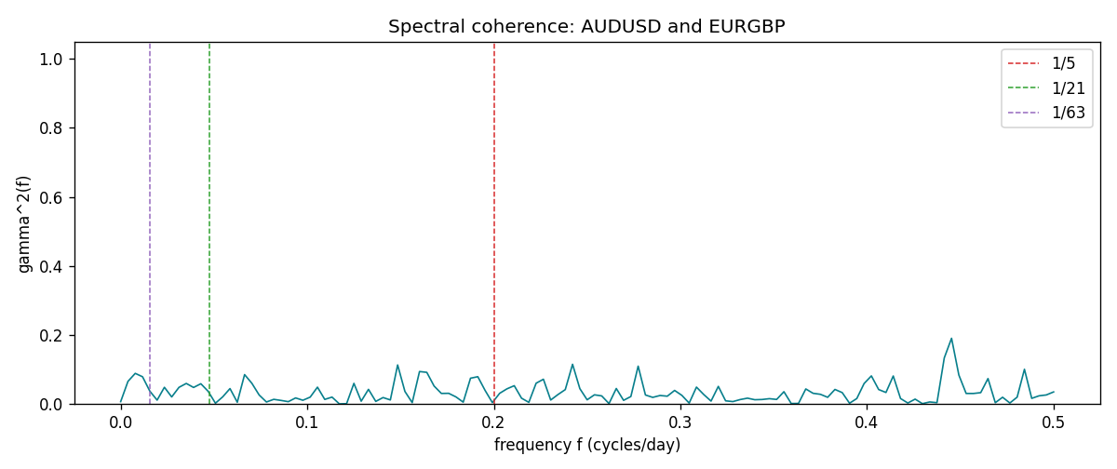

Data report
Matched rows and the coherence sheet are in the sibling Excel workbook named AUDUSD-EURGBP_Spectral_D1.xlsx. Embedding all rows as a Word table is impractical; this file holds column summaries and the first and last 15 matched rows.
Columns: time, AUDUSD_open, EURGBP_open, AUDUSD_high, EURGBP_high, AUDUSD_low, EURGBP_low, AUDUSD_close, EURGBP_close, AUDUSD_tick_volume, EURGBP_tick_volume, AUDUSD_spread, EURGBP_spread, AUDUSD_real_volume, EURGBP_real_volume, AUDUSD_log_return, EURGBP_log_return
Column summaries (matched calculation rows)
column | count | mean | std | min | 25% | 50% | 75% | max
AUDUSD_open | 7198 | 0.75202191 | 0.13526259 | 0.4785 | 0.6611175 | 0.731685 | 0.8091425 | 1.10284
EURGBP_open | 7198 | 0.78667202 | 0.09675257 | 0.5734 | 0.687325 | 0.83369 | 0.8651775 | 0.9769
AUDUSD_high | 7198 | 0.7560731 | 0.13582215 | 0.4878 | 0.6648025 | 0.7351 | 0.8153975 | 1.10795
EURGBP_high | 7198 | 0.7897492 | 0.09712763 | 0.5789 | 0.6894 | 0.836595 | 0.86804 | 0.9799
AUDUSD_low | 7198 | 0.74796393 | 0.1345766 | 0.4775 | 0.6578225 | 0.727775 | 0.804275 | 1.0975
EURGBP_low | 7198 | 0.7839722 | 0.09657024 | 0.5682 | 0.6853 | 0.831475 | 0.8627775 | 0.9661
AUDUSD_close | 7198 | 0.75206897 | 0.13524509 | 0.4786 | 0.661255 | 0.7318 | 0.8092725 | 1.10169
EURGBP_close | 7198 | 0.78671595 | 0.09675201 | 0.5735 | 0.687525 | 0.83375 | 0.865285 | 0.977
AUDUSD_tick_volume | 7198 | 77378.184 | 138156.24 | 109 | 5445.75 | 43349.5 | 71356.75 | 1234623
EURGBP_tick_volume | 7198 | 86961.088 | 145396.59 | 332 | 6520.25 | 44270 | 81329 | 1424684
AUDUSD_spread | 7198 | 30.809114 | 16.88495 | 0 | 13 | 30 | 50 | 50
EURGBP_spread | 7198 | 21.389692 | 19.14164 | 0 | 4 | 13 | 50 | 50
AUDUSD_real_volume | 7198 | 5.2442754e+09 | 1.2540657e+11 | 0 | 0 | 0 | 0 | 3.811512e+12
EURGBP_real_volume | 7198 | 2.7809077e+10 | 1.3507993e+11 | 0 | 0 | 0 | 0 | 3.5726265e+12
AUDUSD_log_return | 7198 | 2.054e-05 | 0.00754782 | -0.08602525 | -0.00386556 | 0.00027727 | 0.00415374 | 0.0806166
EURGBP_log_return | 7198 | 2.199e-05 | 0.00487197 | -0.03067367 | -0.00262256 | -0.00010006 | 0.00256155 | 0.06075387
First 15 matched rows (selected columns)
time | AUDUSD_log_return | EURGBP_log_return
1999-01-06 | 0.011836351 | -0.013303338
1999-01-07 | 0.0088650256 | 0.011051402
1999-01-08 | 0.00031515916 | -0.004943862
1999-01-11 | 0.0072213815 | -0.0012752393
1999-01-12 | -0.0048608485 | 0.0033970309
1999-01-13 | -0.0078902098 | 0.00042381861
1999-01-14 | -0.002696916 | -0.0019793588
1999-01-15 | 0.007123101 | -0.0076715819
1999-01-18 | 0.00094592471 | 0.00071280921
1999-01-19 | 0.0072225153 | -0.0014261269
1999-01-20 | 0.0012507819 | 0.0019960086
1999-01-21 | 0.00078094498 | -0.00071240297
1999-01-22 | -0.012252745 | -0.0017118406
1999-01-25 | -0.0039591468 | -0.0054402425
1999-01-26 | 0.00047592608 | -0.00057438255
Last 15 matched rows (selected columns)
time | AUDUSD_log_return | EURGBP_log_return
2026-10-13 | 0.0035007712 | 0.00020130374
2026-10-14 | -0.0015193215 | 0.0011241873
2026-10-15 | -0.0075447063 | -0.00087557391
2026-10-16 | 0.0033906408 | -0.0020380844
2026-10-19 | 0.0050859986 | -0.00056950988
2026-10-20 | 0.0034620426 | -0.0035906254
2026-10-21 | 0.0036066384 | -0.00140647
2026-10-22 | -0.0012672558 | -0.0018743924
2026-10-23 | 0.0023765656 | 0.00082421033
2026-10-26 | -0.0032032829 | 0.00013133309
2026-10-27 | 0.0016669876 | -0.0019957343
2026-10-28 | 0.0040915541 | 0.00066967224
2026-10-29 | -0.0040915541 | -0.0011722209
2026-10-30 | 0.0010102376 | -0.0024205543
2026-11-02 | -0.0049184984 | 0.00089940465
First 15 frequency bins
f | gamma2 | phase_rad | period_days
0 | 0.00664107 | 3.1415927 | inf
0.00390625 | 0.06536248 | 1.312065 | 256
0.0078125 | 0.08859184 | 0.59443697 | 128
0.01171875 | 0.07874576 | 0.63055543 | 85.333333
0.015625 | 0.03703259 | 0.60245528 | 64
0.01953125 | 0.01101438 | 1.4490568 | 51.2
0.0234375 | 0.04822053 | 1.9598638 | 42.666667
0.02734375 | 0.02025205 | 1.79159 | 36.571429
0.03125 | 0.04805306 | 0.88951605 | 32
0.03515625 | 0.05938524 | 0.93062736 | 28.444444
0.0390625 | 0.0477113 | 2.6918586 | 25.6
0.04296875 | 0.05849586 | 2.2052855 | 23.272727
0.046875 | 0.03659632 | 1.3390622 | 21.333333
0.05078125 | 0.00209443 | 0.14594659 | 19.692308
0.0546875 | 0.02051443 | 1.1924879 | 18.285714

